Logic Circuit Simplification Homework

Paul Collado

Department of Computer Science

Montclair State University

CMPT281

Theory of Digital Machines

02/18/2015

1. Prove the identity of each of the following Boolean equations using algebraic manipulations
2. !X!Y + XY + !XY = !X + Y

!X!Y + XY + !XY + !XY = ADDED A NEW !XY

!X(!Y + Y) + Y(X + !X) = FACTOR AND SIMPLIFY

!X + Y = !X + Y PROVE

1. !X!Y + X!Y + XY + !X!Y = 1

!X(Y + !Y) + X(!Y + Y) = 1 FACTOR AND SIMPLIFY

!X + X = 1 SOLVE

**1 = 1** PROVE

1. Simplify, using algebraic manipulations
2. XYZ + !XY +XY!Z

XY(!Z + Z) + !XY FACTOR AND SIMPLIFY

XY + !XY

Y(X + !X) FACTOR AND SIMPLIFY

**Y** ANSWER

1. !XYZ + XZ

!X•X + !X•Z + XYZ + XZ EXPAND AND SIMPLIFY

!X•Z + XYZ + XZ

Z(!X + XY + X) FACTOR AND SIMPLIFY

**XYZ**  ANSWER

1. Using DeMorgan’s Theorem, express the following function (use only OR and complement operations)

F = XY + !X!Y + !YZ DOUBLE COMPLEMENT OF ALL

= !(!(XY)) + !(!(!X!Y)) + !(!(!YZ)) Using DeMorgan’s

= **!(!X + !Y) + !(X + Y) + !(Y + !Z) ANSWER**

1. Find the complement of the following expression:
2. X!Y + !XY

!(X!Y + !XY) COMPLEMENT WITH A NEGATIVE

!(X!Y) • !(!XY) DeMorgan’s

(!X + Y) • (X + !Y) MUTIPLYING THE NEGATIVE AND EXPANDING

!XX + !X!Y + XY + Y!Y SIMPLIFIYING

**!X!Y + XY**  ANSWER

1. Draw the logic diagram for the following Boolean expression:
2. (A + B) (C+D) (!A + B +D)

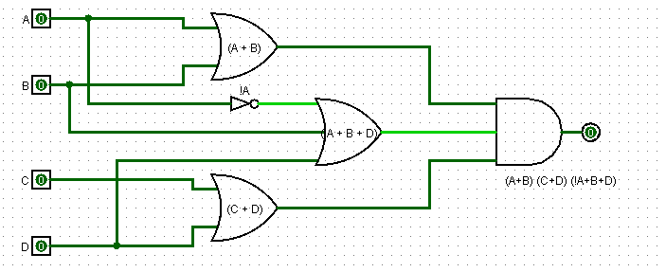

1. Simplify the following expressions using K-map
2. XY + Y!Z + !X!Y!Z

|  |  |  |
| --- | --- | --- |
| XY | Z |  |
| 00 | 1 |  |
| 01 | 1 |  |
| 11 | 1 |  |
| 10 |  |  |

**Answer: !X!Z + Y!Z**

1. Simplify the following expressions by means of a four variable K-map
2. !AD + BD + !BC + A!BD

|  |  |  |  |  |
| --- | --- | --- | --- | --- |
| AB\CD | 00 | 01 | 11 | 10 |
| 00 |  | 1 |  | 1 |
| 01 |  | 1 |  |  |
| 11 |  |  |  |  |
| 10 |  | 1 |  |  |

**Answer: !A!CD + !B!CD + !A!BC!D**

1. ABC + CD + B!CD + !BC

|  |  |  |  |  |
| --- | --- | --- | --- | --- |
| AB\CD | 00 | 01 | 11 | 10 |
| 00 |  |  | 1 | 1 |
| 01 |  | 1 |  |  |
| 11 |  |  |  | 1 |
| 10 |  |  |  |  |

**Answer: !A!BC + !AB!CD + ABC!D**